

**Digital Notes**

**(Subject Name:-Environmental Science and Sustainability)**

**(Subject Code :-BCA-1006)**

BCA

1st year



**UNIT-2**

**Topics to cover: Ecosystems, Biodiversity, and Sustainable Practices:**

Various natural ecosystems, learning about their structure, functions, and ecological characteristics. The importance of biodiversity, the threats it faces, and the methods used for its conservation. Ecosystem resilience, homeostasis, and carrying capacity, emphasizing the need for sustainable ecosystem management. Strategies for in situ and ex situ conservation, nature reserves, and the significance of India as a mega diverse nation.

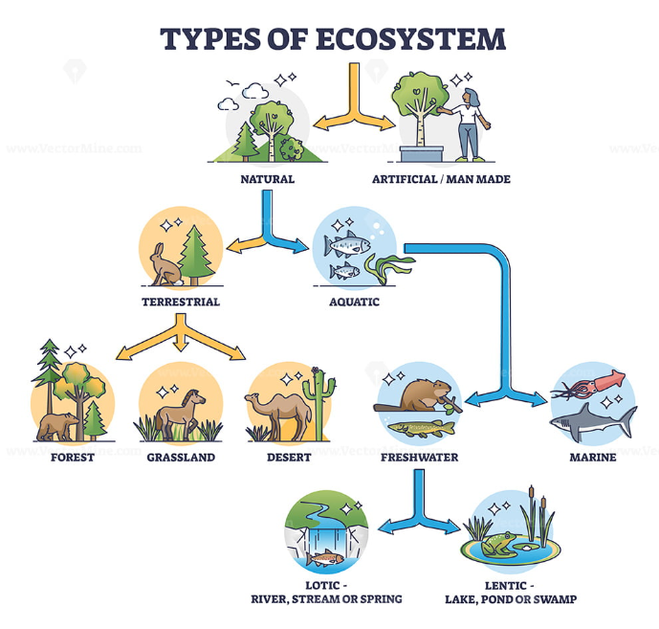

**• An ecosystem is a functional unit consisting of living organisms (biotic components) interacting with the non-living environment (abiotic components) in a defined area.**

**• Word origin:**

* Eco = environment
* System = organized unit of interactions

**🌱 Natural Ecosystems**

**1. Various Natural Ecosystems**

Natural ecosystems are self-sustaining biological communities where living organisms interact with their physical environment without significant human intervention.  
They are broadly classified as:

* **Terrestrial Ecosystems**
  + **Forest Ecosystem** – High biodiversity, dense vegetation, major carbon sink.
  + **Grassland Ecosystem** – Dominated by grasses, support grazing animals, moderate rainfall.
  + **Desert Ecosystem** – Extreme temperatures, scarce water, drought-resistant plants & animals.
  + **Tundra Ecosystem** – Cold, treeless, permafrost soil, mosses & lichens dominant.
* **Aquatic Ecosystems**
  + **Freshwater Ecosystem** – Rivers, lakes, ponds, wetlands (support fish, amphibians, birds).
  + **Marine Ecosystem** – Oceans, seas, coral reefs, estuaries (largest ecosystem on Earth).

**2. Structure of Ecosystems**

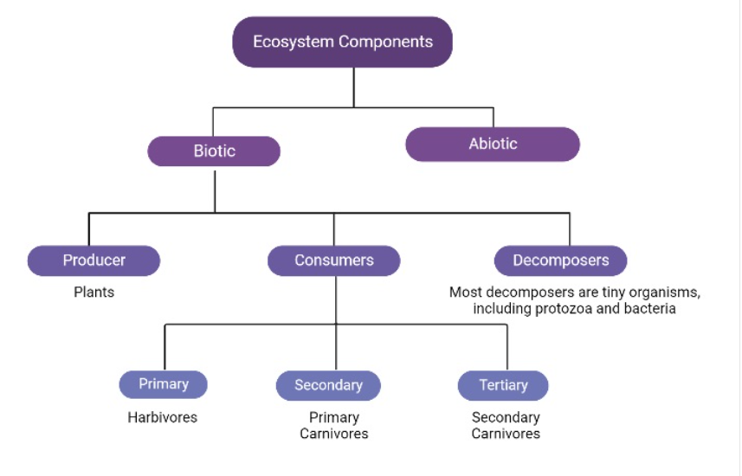

Every ecosystem has two main components:

* **Biotic Components (Living)**
  + **Producers (Autotrophs) –** Green plants, algae (make food via photosynthesis).
  + **Consumers (Heterotrophs) –**
    - Primary (herbivores),
    - Secondary (carnivores),
    - Tertiary (top carnivores).
  + **Decomposers (Saprotrophs) –** Bacteria, fungi (break down dead matter, recycle nutrients).
* **Abiotic Components (Non-Living)**
  + **Physical:** sunlight, temperature, water, air, soil.
  + **Chemical:** nutrients (nitrogen, phosphorus), gases (CO₂, O₂).

**3. Functions of Ecosystems**

Ecosystems perform essential life-supporting functions:

1. **Energy Flow**
   * Solar energy → captured by producers → flows through food chains (10% energy transfer rule).
2. **Nutrient Cycling (Biogeochemical Cycles)**
   * Recycling of essential elements like carbon, nitrogen, water, and phosphorus.
3. **Ecological Balance**
   * Maintain predator-prey relationships, biodiversity, and population control.
4. **Productivity**
   * Gross Primary Productivity (GPP): Total photosynthesis.
   * Net Primary Productivity (NPP): GPP – respiration = usable biomass.
5. **Regulation Services**
   * Climate regulation, soil fertility, water purification, carbon storage.

**4. Ecological Characteristics of Ecosystems**

* **Diversity** – Variety of species and genetic variation ensures stability.
* **Dynamic Nature –** Ecosystems are constantly changing due to natural & human activities.
* **Self-Regulation** – Ability to recover from disturbances (resilience).
* **Interdependence** – Organisms depend on each other (food chains, symbiosis).
* **Succession** – Gradual change in ecosystems (e.g., bare land → forest).
* **Carrying Capacity –** Maximum population size the ecosystem can support sustainably.

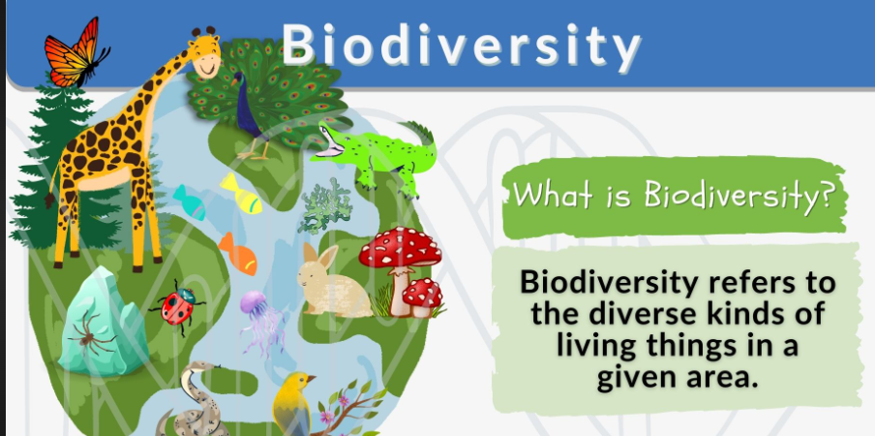

**🌿 Biodiversity**

**Definition: Biodiversity refers to the variety of life on Earth at all levels – genes, species, and ecosystems. It represents the biological wealth of our planet.**

**1. Importance of Biodiversity**

**(a) Ecological Importance**

* Maintains ecosystem balance (predator-prey, nutrient cycling).
* Provides ecosystem services: pollination, oxygen production, soil fertility, water purification.
* Increases ecosystem resilience to disturbances (floods, droughts, climate change).

**(b) Economic Importance**

* Food resources: crops, livestock, fish.
* Medicinal resources: many drugs (quinine, morphine, penicillin) are plant/microbe-derived.
* Industrial products: timber, fibers, oils, latex, paper, biofuels.
* Provides jobs in agriculture, forestry, fisheries, ecotourism.

**(c) Cultural & Aesthetic Importance**

* Symbol of cultural heritage (sacred groves, rituals).
* Recreation & tourism (wildlife sanctuaries, national parks).
* Inspiration for art, literature, and spiritual values.

**(d) Scientific Importance**

* Source for research & education.
* Genetic resources for improving crops and livestock.
* Helps understand evolution and adaptation.

**2. Threats to Biodiversity**

1. **Habitat Loss & Fragmentation**
   * Deforestation, urbanization, agriculture expansion.
   * Loss of forests like the Amazon & Sundarbans.
2. **Overexploitation**
   * Excessive hunting, fishing, and logging.
   * Leads to extinction (e.g., passenger pigeon, dodo).
3. **Pollution**
   * Industrial waste, plastics, pesticides (DDT).
   * Causes soil infertility, water pollution, biomagnification.
4. **Climate Change & Global Warming**
   * Melting glaciers, coral bleaching, altered migration patterns.
   * Shifts in species distribution.
5. **Invasive Alien Species**
   * Non-native species (e.g., water hyacinth, lantana) outcompete local species.
6. **Natural Causes (lesser but impactful)**
   * Volcanoes, earthquakes, droughts, floods, etc.

**3. Methods for Biodiversity Conservation**

**(a) In-situ Conservation (within natural habitat)**

* Protected areas:
  + National Parks – Keoladeo (Bharatpur), Kaziranga.
  + Wildlife Sanctuaries – Gir (Asiatic Lion), Periyar.
  + Biosphere Reserves – Nilgiri, Nanda Devi.
* Sacred Groves: religiously protected patches of forest.
* Maintains evolutionary processes and species interactions.

**(b) Ex-situ Conservation (outside natural habitat)**

* **Botanical Gardens –** cultivate rare/endangered plants.
* **Zoological Parks –** breed endangered animals.
* **Seed Banks & Gene Banks** – store genetic material for future.
* **Cryopreservation** – storing gametes/embryos at very low temperature.

**(c) Legislation & Awareness**

* **Wildlife Protection Act (1972**), Biological Diversity Act (2002) in India.
* **CITES (1975)** – international treaty to control trade in endangered species.
* Public awareness campaigns, eco-clubs, and NGOs.

**(d) Sustainable Practices**

* Afforestation, social forestry.
* Organic farming, eco-friendly tourism.
* Rational use of natural resources.

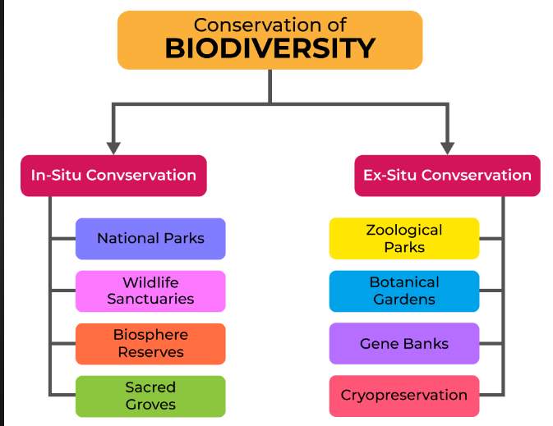

**🌱 Ecosystem Concepts**

**1. Ecosystem Resilience**

* **Definition:** The ability of an ecosystem to recover from disturbances (like floods, fires, pollution, or human activities) and return to its original state.
* **Importance:**
  + Maintains biodiversity.
  + Ensures continuity of ecosystem services (clean air, water, food, etc.).
  + Helps ecosystems adapt to climate change.
* Example: A forest regrowing after a wildfire.

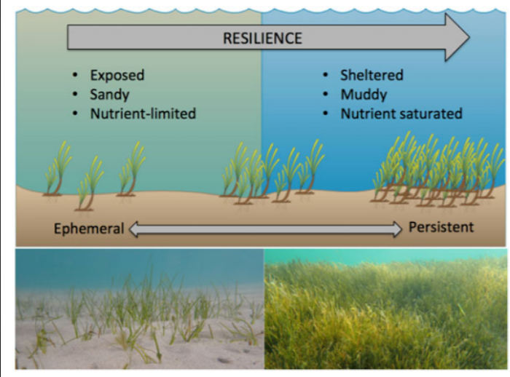

**2. Homeostasis**

* **Definition:** The natural tendency of an ecosystem to maintain internal stability and balance despite external changes.
* **Mechanism:** Achieved through feedback loops (e.g., predator-prey balance, nutrient cycling).
* **Importance:**
  + Prevents overpopulation of species.
  + Maintains environmental conditions suitable for life.
* **Example:** Increase in deer → more food for tigers → tiger population rises → deer population decreases → balance restored.
* 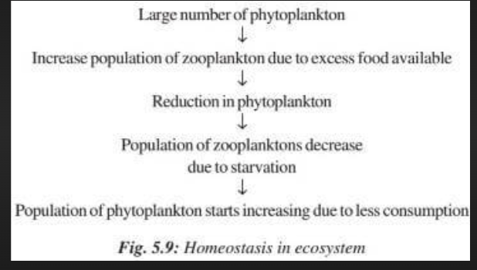 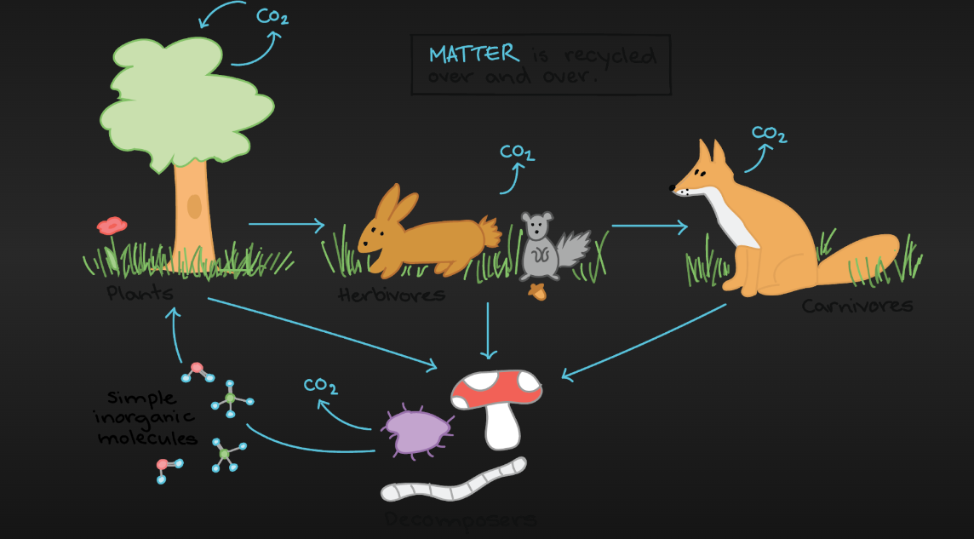

**3. Carrying Capacity**

* **Definition:** The maximum population of a species that an ecosystem can support sustainably, without degrading resources.
* **Factors Affecting:**
  + Food and water availability.
  + Habitat space.
  + Predation and disease.
* **Importance:**
  + Prevents overexploitation of resources.
  + Ensures long-term survival of species.
* **Example:** If too many fish are added to a pond, oxygen and food run out, leading to population collapse.
* 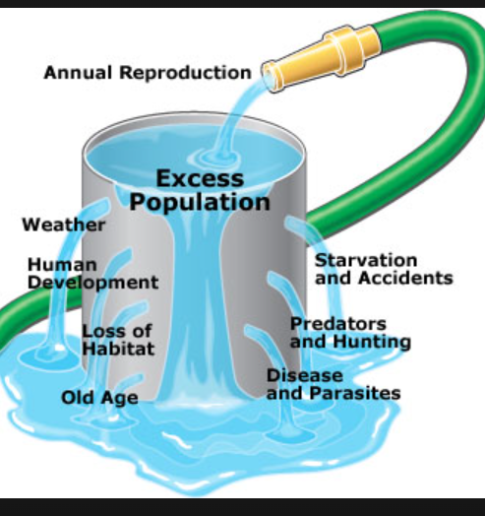

**4. Need for Sustainable Ecosystem Management**

* **Why?**
  + Human activities (deforestation, pollution, overfishing, industrialization) reduce resilience, disturb homeostasis, and exceed carrying capacity.
* **Goals of Sustainable Management:**
  + Balance use and conservation of natural resources.
  + Maintain resilience by protecting biodiversity.
  + Avoid exceeding carrying capacity by regulating population growth and resource use.
  + Promote renewable energy & eco-friendly practices.
* **Examples:**
  + Afforestation and reforestation.
  + Sustainable agriculture and fishing.
  + Waste management and pollution control.
  + Protected areas and wildlife sanctuaries.

✅ **Summary:**

* Resilience = Recovery ability.
* Homeostasis = Self-regulation & balance.
* Carrying capacity = Maximum sustainable limit.
* Sustainable management = Ensuring ecosystems remain healthy for present and future generations.

**🌱 Conservation Strategies**

**1. In-situ Conservation Strategies**

Conservation of species in their natural habitat.

* Protects entire ecosystems and ecological processes.
* Allows species to evolve naturally.
* **Examples:**
  + Biosphere Reserves – Nilgiri, Sundarbans
  + National Parks – Jim Corbett, Kaziranga
  + Wildlife Sanctuaries – Bharatpur, Gir

**2. Ex-situ Conservation Strategies**

Conservation of species outside their natural habitat.

* Used for endangered or critically threatened species.
* Provides controlled conditions for survival and breeding.
* **Examples:**
  + Seed Banks – to preserve plant genetic material
  + Zoos and Botanical Gardens – protection & research
  + Cryopreservation – preserving gametes/tissues at low temperatures

**3. Nature Reserves**

* Areas set aside exclusively for protection of biodiversity.
* Prevent human exploitation and maintain ecological balance.
* **Types:**
  + Strict Nature Reserves – highly protected, no human activity allowed.
  + Wildlife Reserves – regulated human activity, focus on wildlife protection.

**4. Significance of India as a Mega-Diverse Nation**

* India is one of 17 mega-diverse nations in the world.
* **Features:**
  + Covers 2.4% of Earth’s land, but hosts 7-8% of recorded species.
  + Rich in flora and fauna – ~47,000 plant species & 90,000 animal species.
  + Hotspots: Himalaya, Indo-Burma, Indo-Malayan, and Western Ghats.
  + Strong cultural tradition of sacred groves and community-based conservation.

✅ **Summary:**

* *In-situ* = Protect in natural habitat.
* *Ex-situ* = Protect outside habitat.
* Nature reserves safeguard biodiversity.
* India’s mega-diversity makes conservation highly significant for global ecology.